518 – Image String Searching Tool
Team Information

Team Name ___________________________________________________

Results Email ___________________________________________________

Examination Time Frame to
Instructions

Description:
Image String Searching Tool
Requirements Document

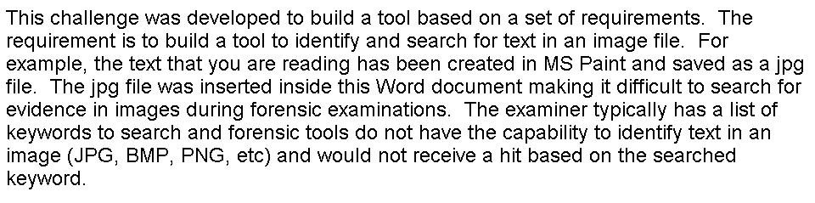

There have been solutions to identify text in images that this could be the basis for this tool such as, optical character recognition (OCR) technology and identification of captcha characters. However, there does not seem to be a tool developed for forensic purposes.

Items to include with your submission as required by the DC3 Challenge Rules:
- Provide a completed Tool Development Evaluation Worksheet form
that includes your program’s information, dependencies, and test bed information.
- A completed test plan outlining the steps necessary for a functional test (Template has been provided below)
- Data test case used.
- Compiled binary or binaries

Req # | Requirement
1 | Image String Searching Tool
1.1 | The tool shall have a graphic user interface that can be implemented on a Windows XP or newer platform
1.2 | The tool shall have the ability to accept one or more keywords
1.3 | The tool shall have the ability to identify text in JPG, BMP, PNG, and GIF files
1.4 | The tool shall have the ability to search for text in JPG, BMP, PNG, and GIF files
1.5 | The tool shall have the ability to identify text in JPG, BMP, PNG, and GIF files embedded in MS Office and PDF documents
1.6 | The tool shall have the ability to search text in JPG, BMP, PNG, and GIF files embedded in MS Office and PDF documents
1.7 | The tool shall have the ability to export the identified files from positive results of search hits.
1.8 | The tool shall have the ability to search an image file
1.9 | The tool shall have the ability to search documents on a live system
2.0 | Complete documentation, with operating instructions, methodology, and screen shots from testing (as required by the rules), are provided with the submittal

**See next page for test plan**
Test Plan

1 Image String Searching Tool

1.1 The tool shall have a graphic user interface that can be implemented on a Windows XP or newer platform
Steps | Expected Results | Actual Results | Pass / Fail | Comments
1
2
3

1.2 The tool shall have the ability to accept one or more keywords
Steps | Expected Results | Actual Results | Pass / Fail | Comments
1
2
3

1.3 The tool shall have the ability to identify text in JPG, BMP, PNG, and GIF files
Steps | Expected Results | Actual Results | Pass / Fail | Comments
1
2
3

1.4 The tool shall have the ability to search for text in JPG, BMP, PNG, and GIF files
Steps | Expected Results | Actual Results | Pass / Fail | Comments
1
2
3

1.5 The tool shall have the ability to identify text in JPG, BMP, PNG, and GIF files embedded in MS Office and PDF documents
Steps | Expected Results | Actual Results | Pass / Fail | Comments
1
2
3

1.6 The tool shall have the ability to search text in JPG, BMP, PNG, and GIF files embedded in MS Office and PDF documents
Steps | Expected Results | Actual Results | Pass / Fail | Comments
1
2
3

1.7 The tool shall have the ability to export the identified files from positive results of search hits
Steps | Expected Results | Actual Results | Pass / Fail | Comments
1
2
3

1.8 The tool shall have the ability to search an image file
Steps | Expected Results | Actual Results | Pass / Fail | Comments
1
2
3

1.9 The tool shall have the ability to search documents on a live system
Steps | Expected Results | Actual Results | Pass / Fail | Comments
1
2
3

2.0 Complete documentation, with operating instructions, methodology, and screen shots from testing (as required by the rules), are provided with the submittal
Steps | Expected Results | Actual Results | Pass / Fail | Comments
1

